**Laboratory 08**: Diodes Part I

(Edit this document as needed)

Partner 1: __________Saaif Ahmed________________

Partner 2: __________John Gonzalez_________________

*Part A*

Brief description of Diode experiment:

Determine the characteristics of a diode when different voltages are across it, and observe the current through the diode at those voltages. The diode, at specific voltages will allow a set amount of current to flow through.

Plot of the current through R1 vs. the voltage source (LTSpice).

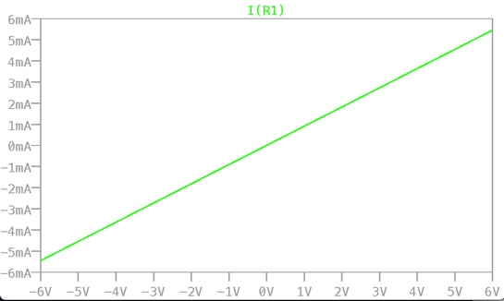

Plot of the current through R1 vs. the voltage across R1 (LTSpice).

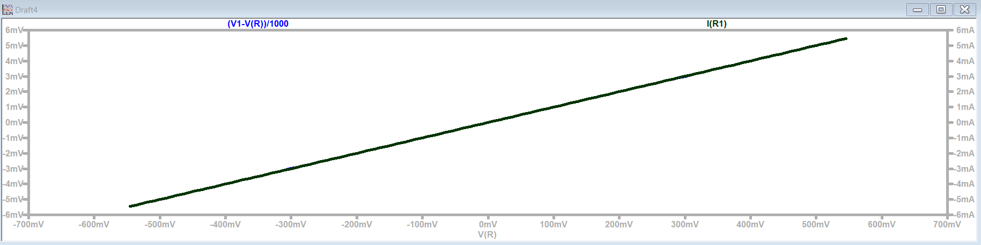

Plot of the current through the Diode vs. the voltage across the Diode, with annotations. (LTSpice).

Activation Voltage

0.7V

Blue: Current of Resistor

Black: Current of Diode

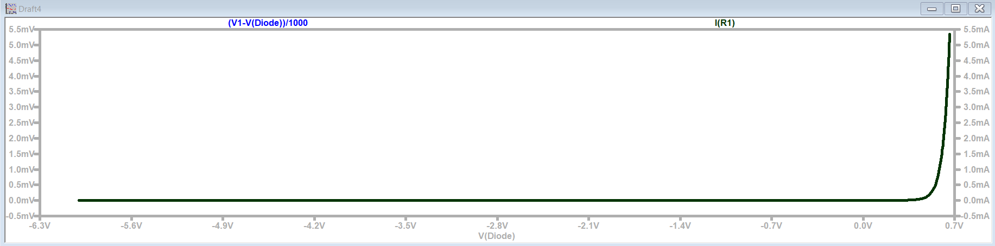

Reverse current at VDiode = -4V

|  |  |
| --- | --- |
| Diode Current | -2.5nA |

Forward current at a few voltages when VDiode = > 0

|  |  |  |
| --- | --- | --- |
| Diode voltage | Diode current  (LTspice) | Diode current  (spec sheet) |
| 583mV | 1mA | 1mA |
| 617mV | 2mA | 2mA |
| 636mV | 3mA | 3mA |
| 648mV | 4mA | 4mA |

How do the simulated currents and spec sheet currents compare for the indicated diode voltages?

The simulated current and spec sheet currents are within reasonable error of each other. They are essentially exact.

Verification of Diode circuit/results: TA/Instructor’s initials ____jb 1/14____

Plots of the voltage across the diode and current through the resistor (diode) as a function of time, with annotations (Discovery Board).

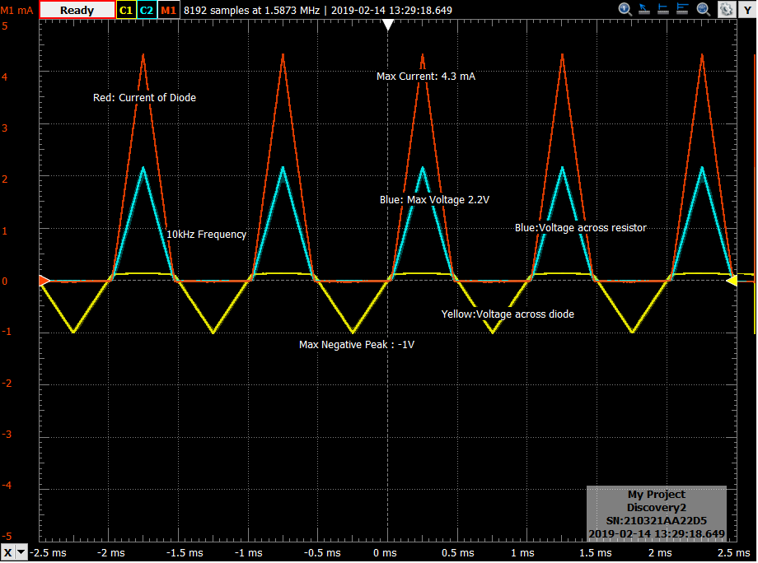

Plot of the current through the diode as a function of time, using the Math channel on the Oscilloscope (Discovery Board).



Plot of diode current vs. diode voltage (I-V curve) (Discovery Board).

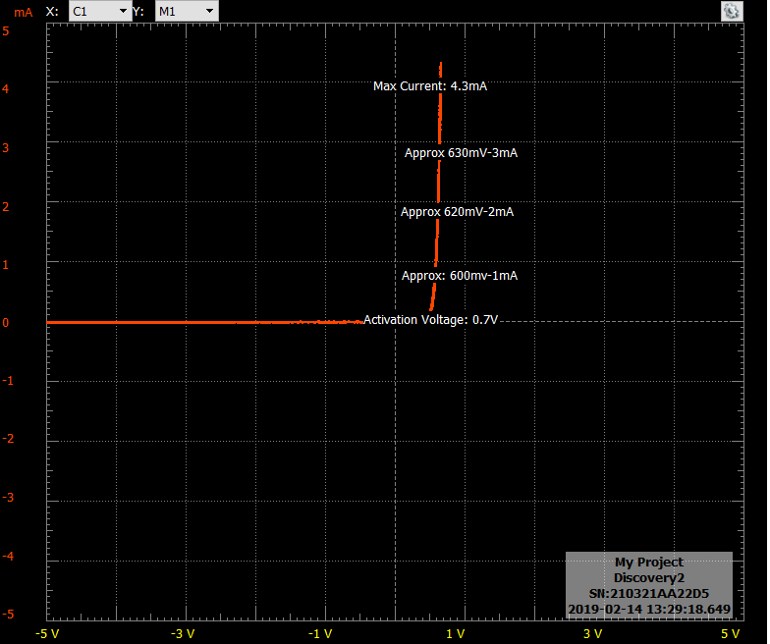

*Part B*

Brief description of Rectifier experiment:

Analyze the characteristics of different rectifier circuits (half/full), build them, and compare them to each other. Observe how an AC wave is converted to a DC signal from these circuits.

Plot of the source voltage and load voltage for a half-wave rectifier circuit, including annotations (Discovery Board).



Plot of the source voltage and load voltage for a half-wave rectifier circuit with a smoothing (4.7μF) capacitor, including annotations (Discovery Board).



The resistor voltage is now essentially constant.

Plot of the source voltage and load voltage for a full-wave rectifier circuit, including annotations (Discovery Board).



Plot of the source voltage and load voltage for a full-wave rectifier circuit with a smoothing (4.7μF) capacitor, including annotations (Discovery Board).



_

Verification of circuit/results: TA/Instructor’s initials ________yl_____________

Describe the differences between the half-wave rectifier and the full-wave rectifier.

The half wave rectifier only retains half the period of an AC wave. The portion of the AC wave that is positive is retained in the rectifier circuit, the other half is lost. The Full wave retains information for both the positive half of the AC and coverts the negative half to positive and send the signal out.

Describe how adding a smoothing capacitor to the load affected the load voltage.

The capacitor would retain a constant level that was essentially DC as it would continuously be charged by the positive waves of the rectifier.

What effect does frequency have when considering smoothing?

An increase in frequency will make the signal tend towards a true DC level. The capacitor will be charging and discharging at an increasing rate, holding the voltage of the rectifier as close as possible to the peak voltage of the AC signal.